Project Design Phase-II
Data Flow Diagram & User Stories

Date | 23/09/2026
Team ID | SWTID-2026-5963
Project Name | AI BlogNest
Maximum Marks | 4 Marks

DFD Level 0 (Context Level Diagram)

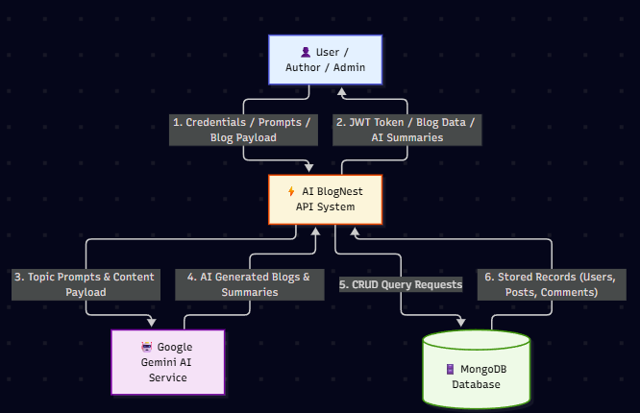

User Stories:
User Type | Functional Requirement (Epic) | User Story Number | User Story / Task | Acceptance criteria | Priority | Release
User | User Registration | USN-1 | As a user, I can register for an account by submitting my name, email, password, and pen name | Account created successfully with password encrypted. | High | Sprint-1
User | User Authentication | USN-2 | As a user, I can log into the system with my registered email and password | System validates credentials and returns a secure JWT access token | High | Sprint-1
Author | Blog Management | USN-3 | As a user, I can create and publish new blog posts with a title, content body, and category | Post record is created in MongoDB and returned with an _id and timestamp. | High | Sprint-2
User | AI Blog Generation | USN-4 | As a user, I can enter a topic prompt to automatically generate full blog content using AI | Google Gemini API returns structured markdown text for the given topic | High | Sprint-3
User | Blog Discovery | USN-5 | As a user, I can view all published blogs and search/filter by specific categories. | API returns a JSON array containing published blog documents | High | Sprint-2
User | AI Content Summarization | USN-6 | As a user, I can request a concise AI summary of any lengthy blog post | /api/ai/summarize returns a clear summary generated by Gemini AI | Medium | Sprint-3
User | Reader Engagement | USN-7 | As a user, I can leave response comments under published blog posts. | Comment document is linked to the blog _id and saved in MongoDB | Medium | Sprint-2
User (Admin) | User & Content Governance | USN-8 | As an admin user, I can oversee content queues, moderate comments, and manage user roles | System enforces Role-Based Access Control (RBAC) to allow admin overrides | High | Sprint-4

